|  |  |  |  |  |  |  |  |  |  |  |  |
| --- | --- | --- | --- | --- | --- | --- | --- | --- | --- | --- | --- |
|  | | **Hope Foundation’s,**  **Finolex Academy of Management and Technology, Ratnagiri** | | | | | | | | | |
| **Department of Information Technology** | | | | | | | | | |
| Subject name: OLAP LAB | | | | | | | | Subject Code: ITL503 | | | |
| Class | | TE IT | | Semester – V (CBCGS) | | | | Academic year: 2018-19 | | | |
| Name of Student | | **Kazi Jawwad A Rahim** | | | | | **QUIZ Score : 06** | | | | |
| Roll No | | **32** | | | Experiment No. | | | | | 08 | |
| Title**: To develop Data warehouse and create star schema.** | | | | | | | | | | | |
|  | | | | | | | | | | | |
| 1. **Course objectives applicable:**   **LOB1**- Understand the various aspects of data warehousing and dimensional modeling. | | | | | | | | | | | |
| 1. **Course outcomes applicable:**   **LO1**- Apply the knowledge of dimensional modeling | | | | | | | | | | | |
| 1. **Learning Objectives:**  * To be able to design data warehouse. * To be able to apply acquired knowledge for understanding data and select suitable methods for data analysis. | | | | | | | | | | | |
| 1. **Practical applications of the assignment/experiment:**  * Business/ Enterprise application | | | | | | | | | | | |
| **5. Prerequisites**: Knowledge of Database, SQL commands | | | | | | | | | | | |
| **6. Hardware Requirements**:   1. PC with 4GB RAM, 500GB HDD,   **7. Software Requirements:**  1. SQL Server 2012 | | | | | | | | | | | |
|  | | | | | | | | | | | |
| **8. Quiz Questions (if any): (Online Exam will be taken separately batch wise, attach the certificate/ Marks obtained)**  <https://goo.gl/8Wb1ra> | | | | | | | | | | | |
|  | | | | | | | | | | | |
| **9. Experiment/Assignment Evaluation:** | | | | | | | | | | | |
| **Sr. No.** | **Parameters** | | | | | | | | **Marks obtained** | | **Out of** |
| **1** | Technical Understanding (Assessment may be done based on Q & A **or** any other relevant method.) Teacher should mention the other method used - | | | | | | | |  | | 6 |
| **2** | Neatness/presentation | | | | | | | |  | | 2 |
| **3** | Punctuality | | | | | | | |  | | 2 |
| **Date of performance (DOP)** | | |  | | | **Total marks obtained** | | |  | | **10** |
| **Date of checking (DOC)** | | |  | | | **Signature of teacher** | | | | | |

**Results:-**

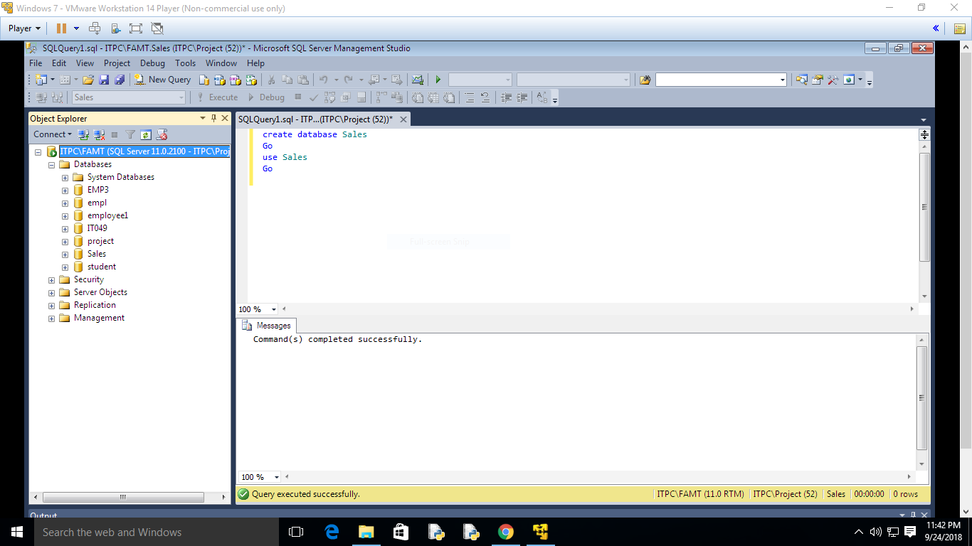

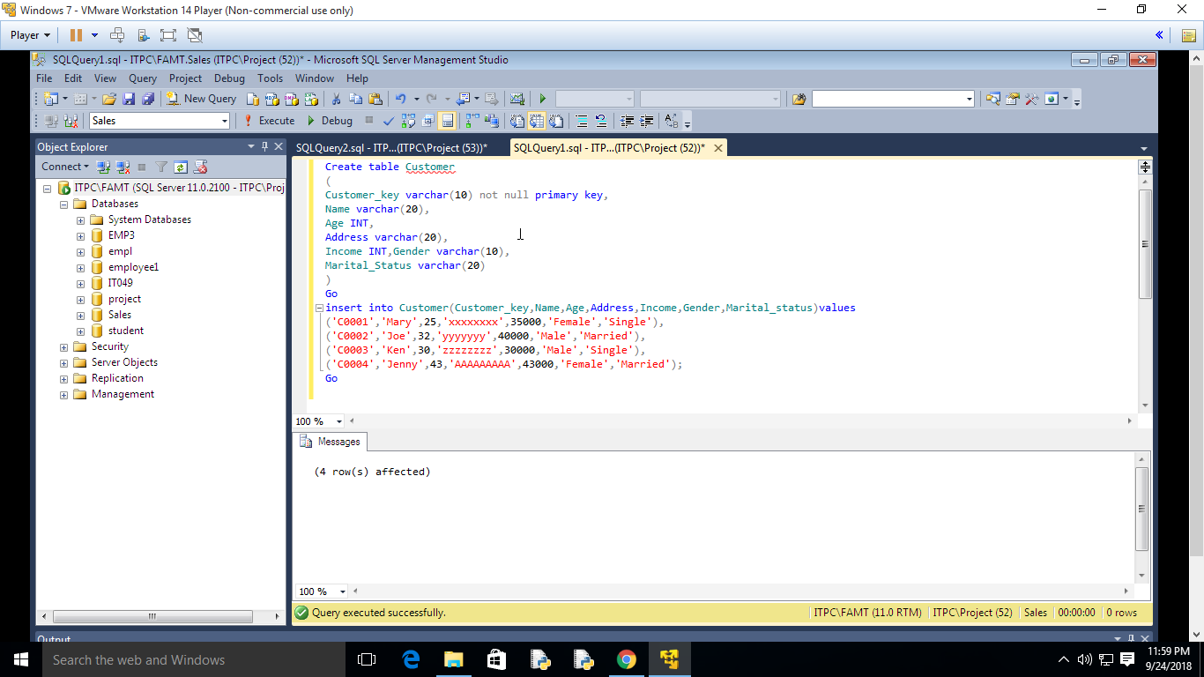

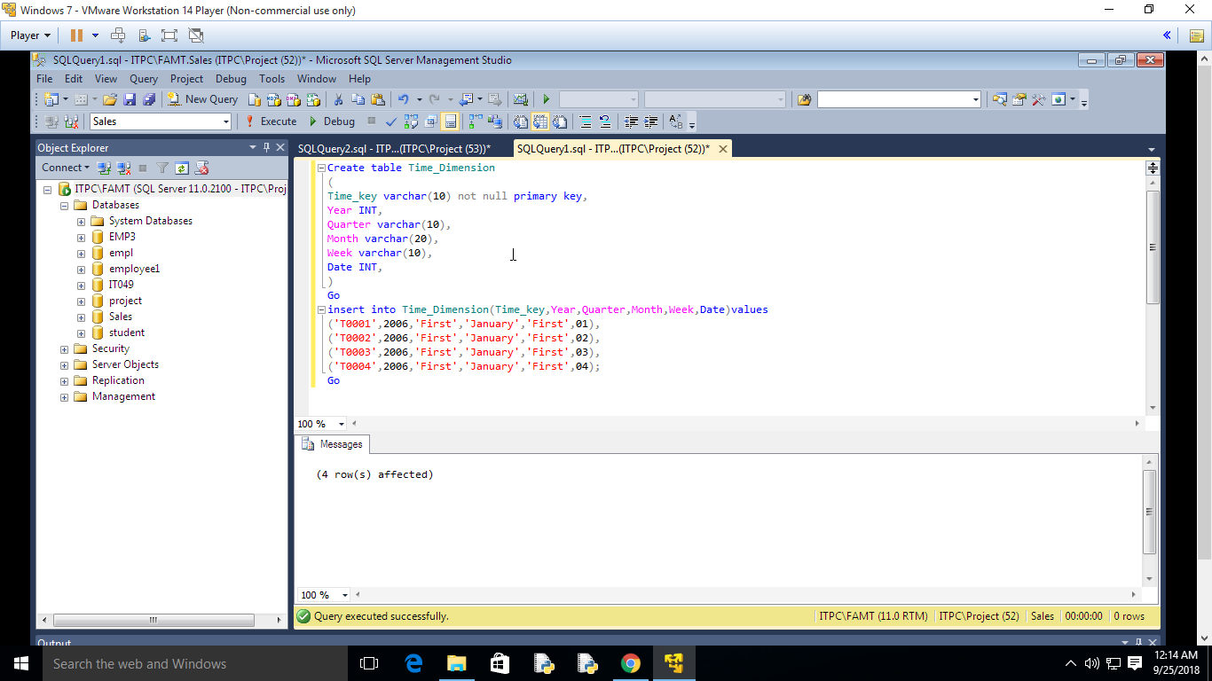

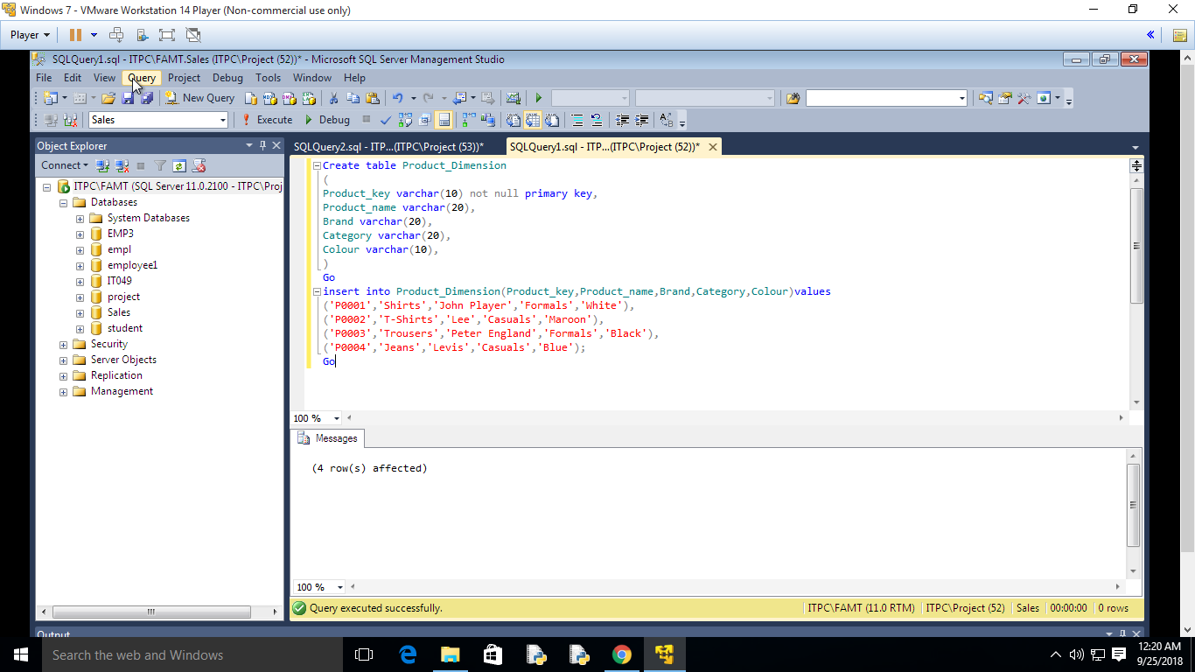

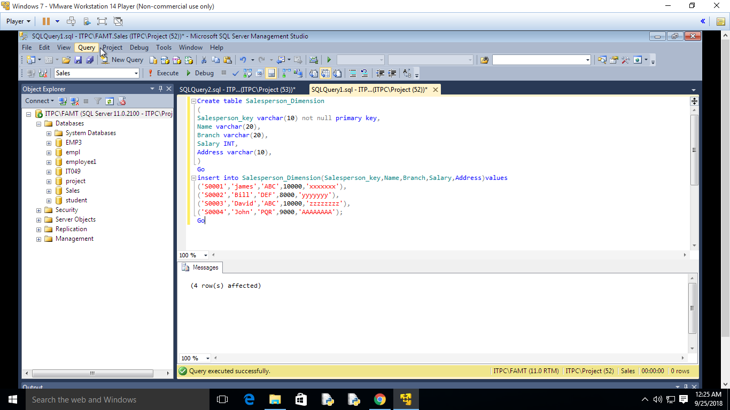

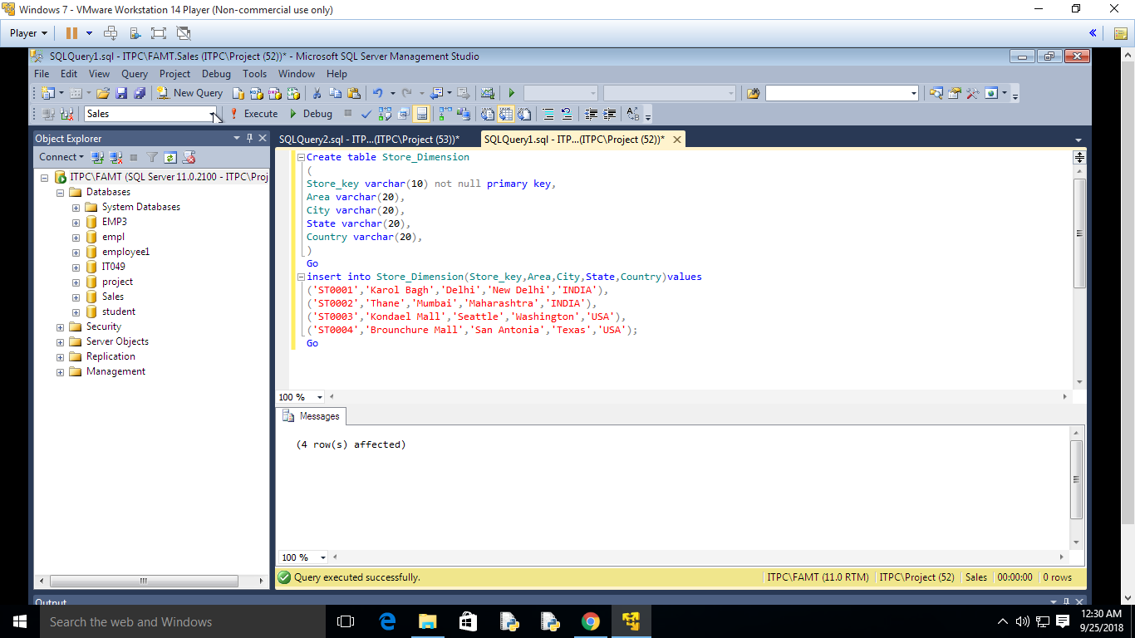

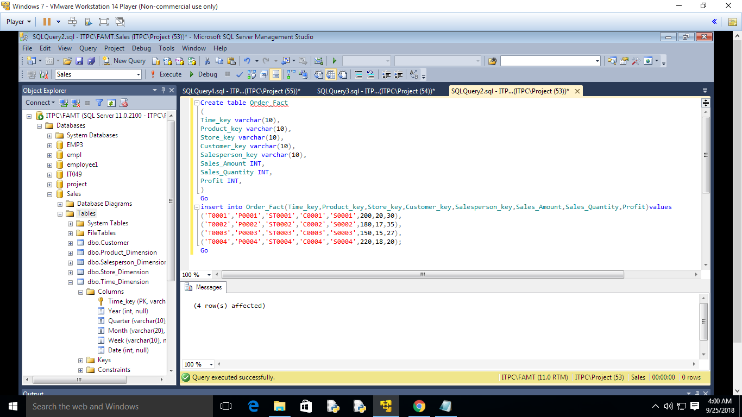

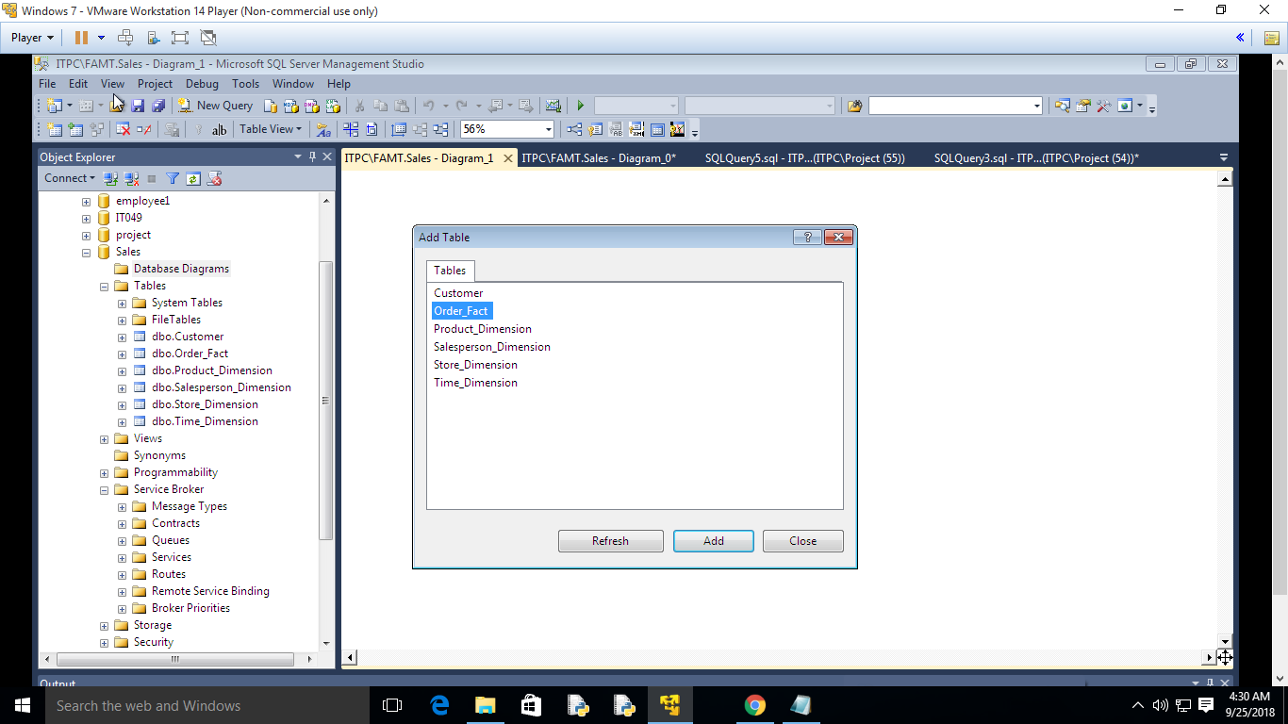

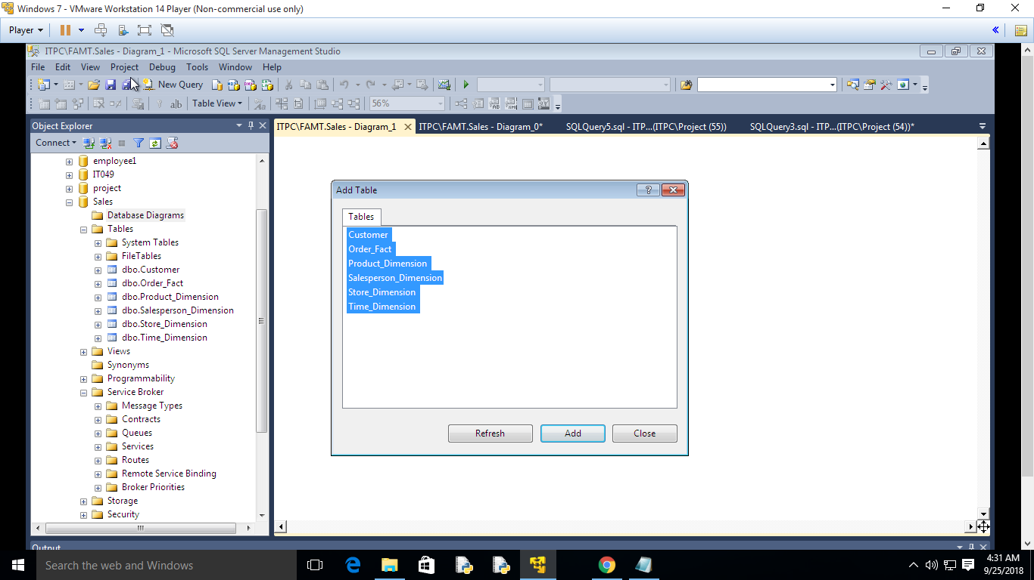

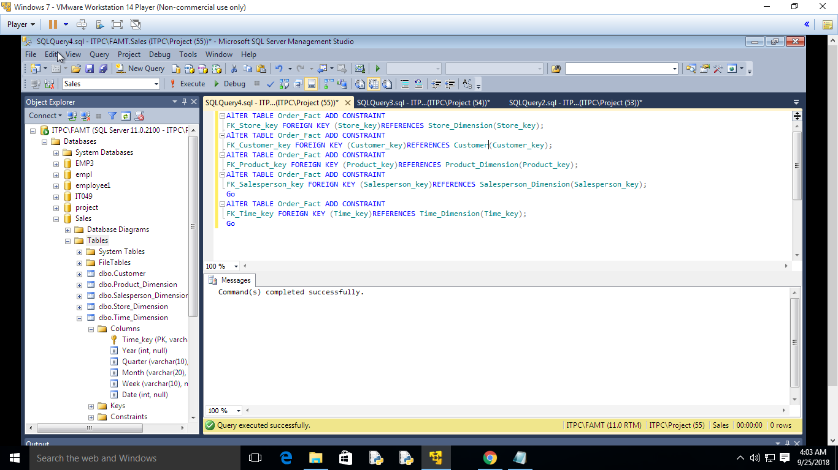

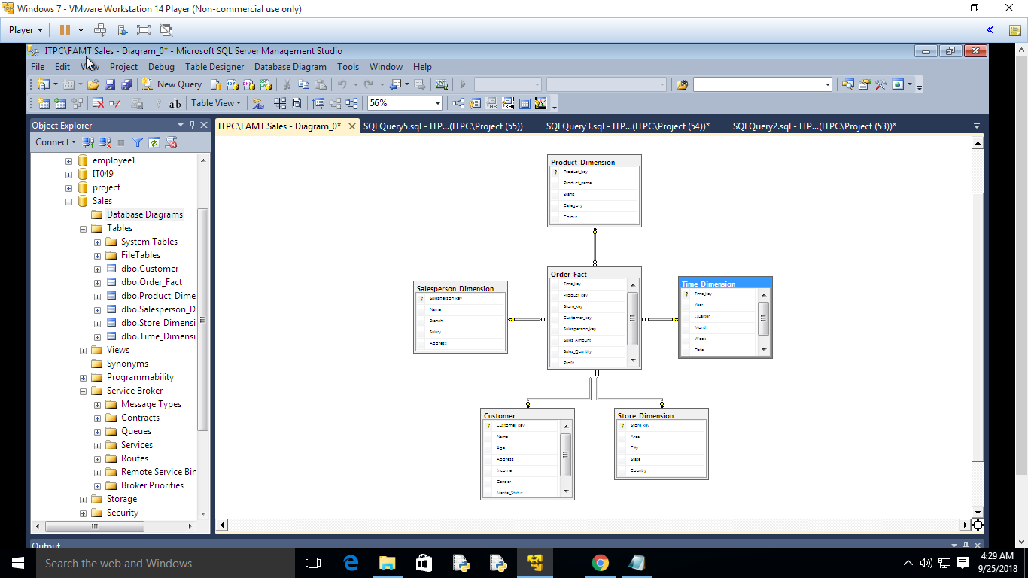

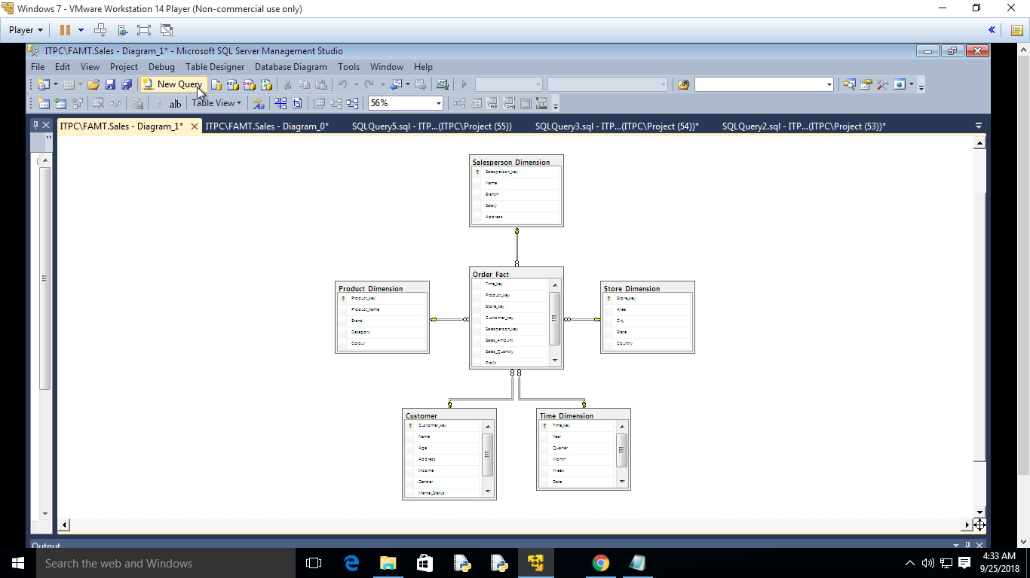

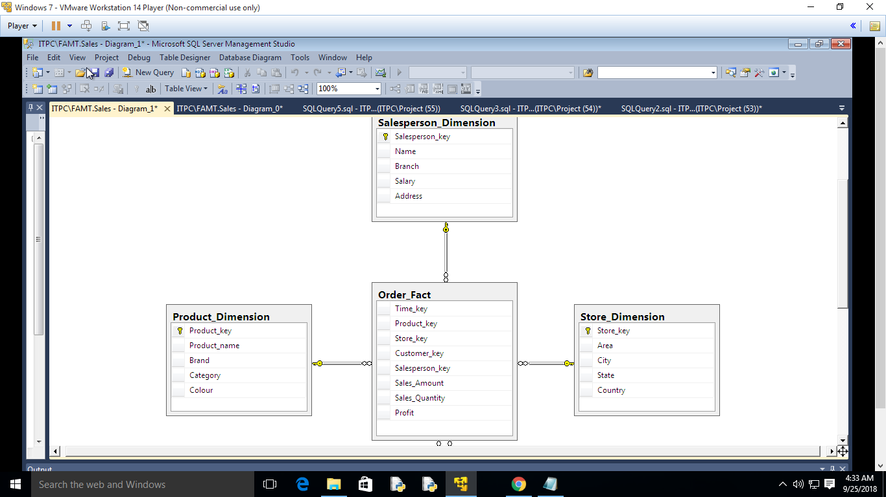

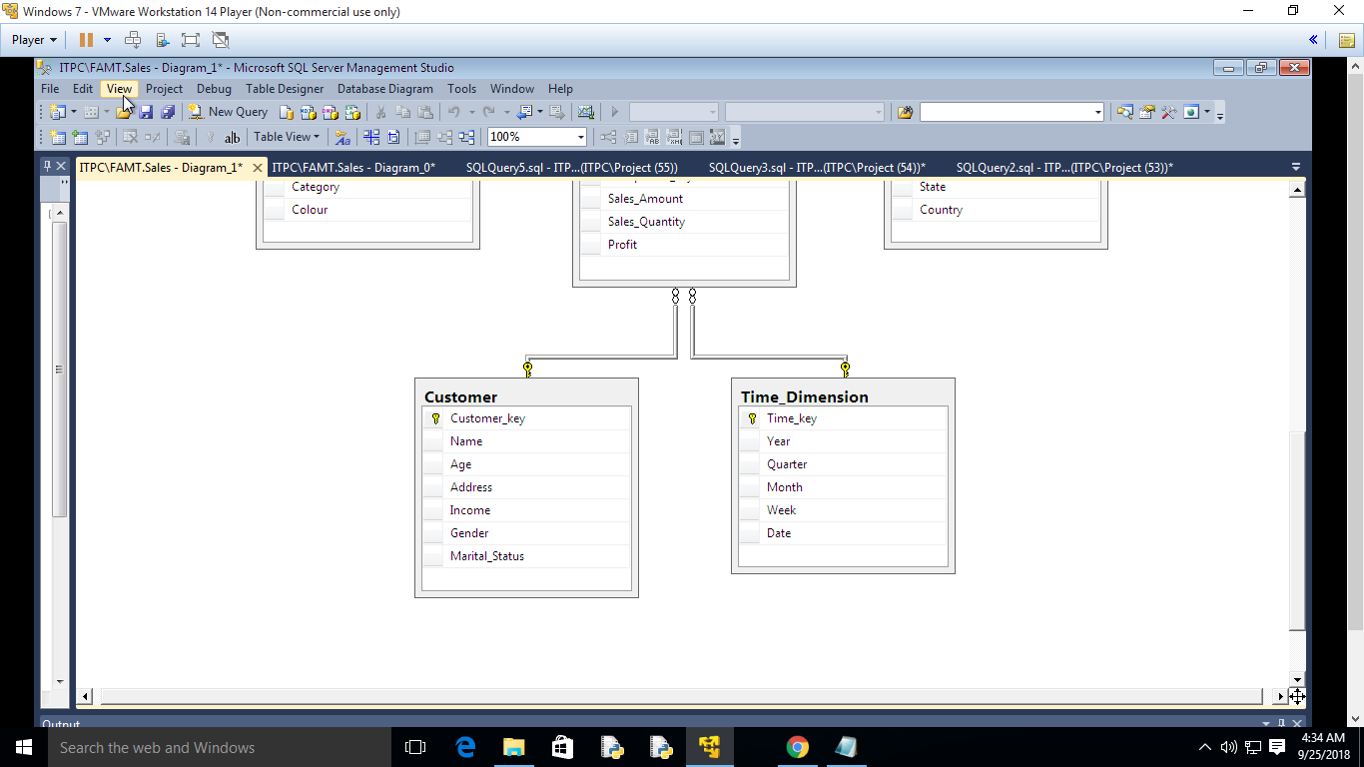

**References** :

1. W. H. Inmon, "Building the Data Warehouse", 3rd edition.

2. Anahory and Murray .,Data warehousing in the real world , Pearson Education/Addison Wesley.

3. https://docs.oracle.com/cd/B10501_01/server.920/a96520/concept.htm